Task No 01: Create a Temperature converter using JavaScript.
Input:
<html lang="en">
<head>
<meta charset="UTF-8">
<meta http-equiv="X-UA-Compatible" content="IE=edge">
<meta name="viewport" content="width=device-width, initial-scale=1.0">
<title>Document</title>
<script>
function myfunction(){
const far=parseFloat(prompt("Enter fahrenheit Temperature"));
let result;
result=(far-32)*0.55;
document.write("Celcius temperature is=" + result)
}
</script>
</head>
<body>
<input type="button" onclick="myfunction()" value="Click here">
</body>
</html>
Output:
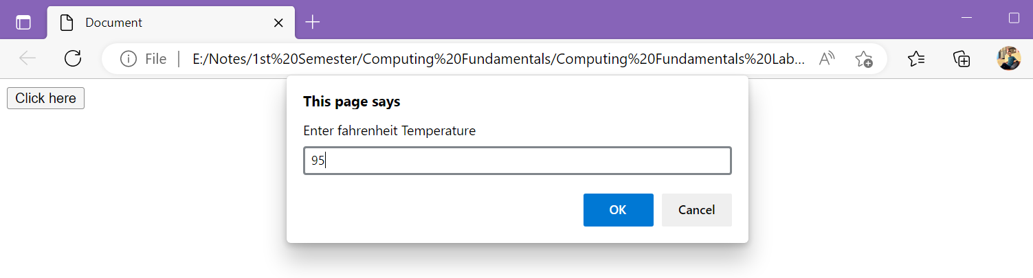

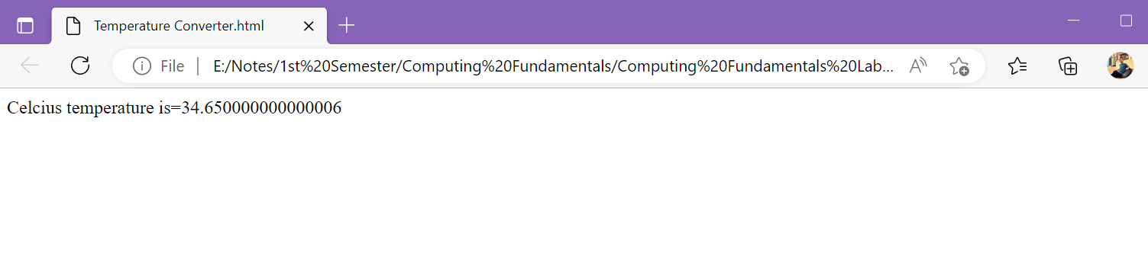
Task No 02: Create a simple Calculator using Prompt Box. Take two inputs from User and ask the operation they want to perform.
Input:
<html>
<head>
<script>
const num1 = parseFloat(prompt('Enter First Number = '));
const num2 = parseFloat(prompt('Enter Second Number = '));
var op = prompt('Enter the operator ( +,-,*,/) :');
let result;

if (op=='+')
{
result = num1 + num2;
}
else if (op == '-')
{
result = num1 - num2;
}
else if (op == '*')
{
result = num1 * num2;
}
else if (op == '/')
{
result = num1/num2;
}

document.write("Result of " +num1+ " "+op+ " "+num2+ " = "+result);
</script>
</head>
</html>
Output:
